- Sign-up here - smith.langchain.com
- Select ‘Traceable Projects’
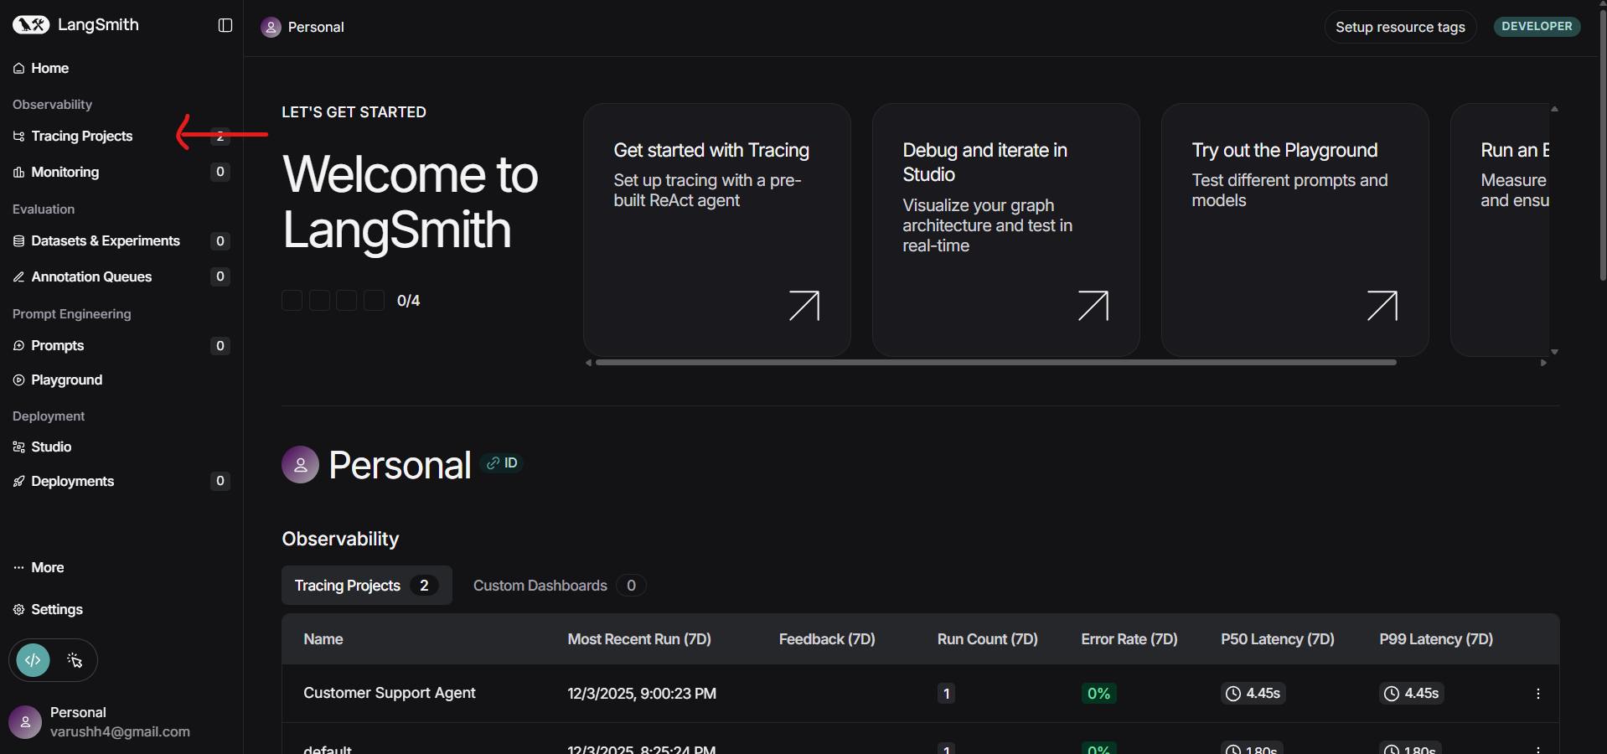
- By selecting ‘New Project’, you’ll land on this page.
Select ‘Trace existing application’ and ‘Generate API Key’
Copy and use the API Key in .env and AWS Secrets Manager.
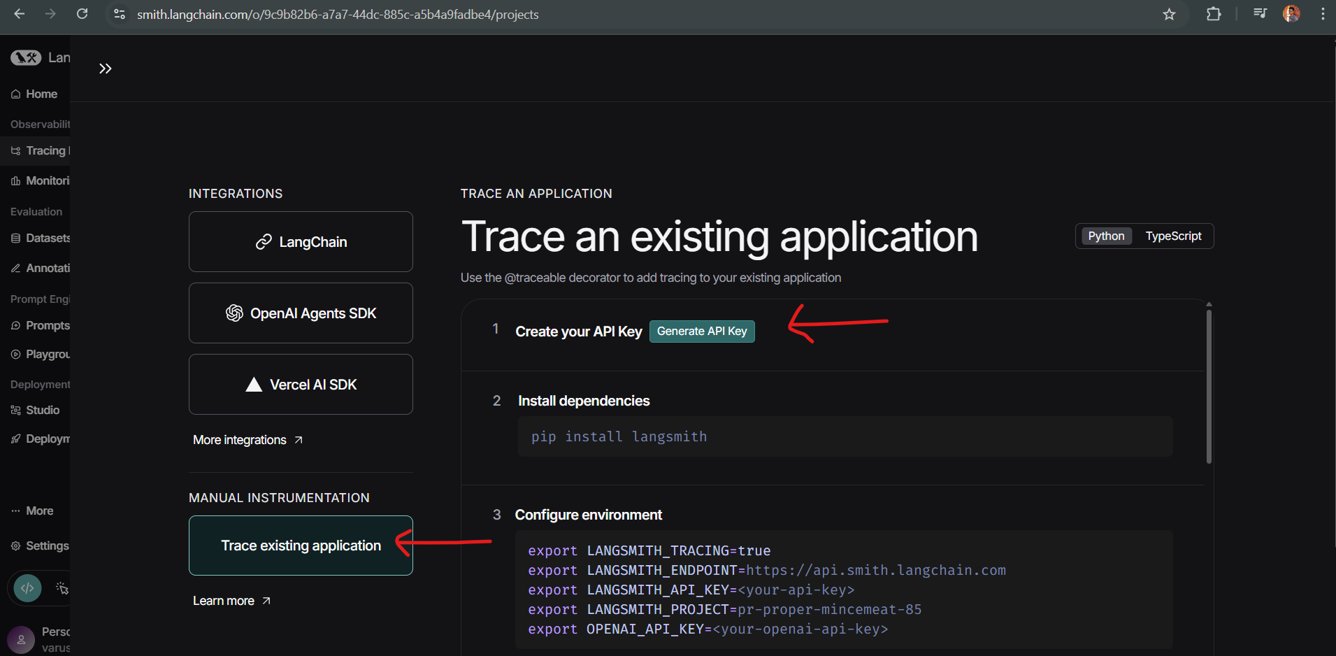

- After running the project in AWS/local env, you will find the project in ‘Tracing Projects’, where you can find the query, response etc.
